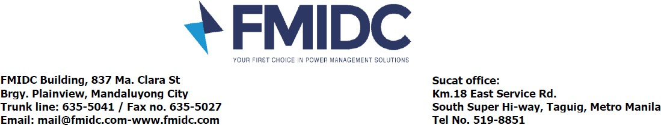

DEFERMENT FORM

Customer: Date Fill out: Branch Name: Branch Address: Branch Code: MSR No.: Date/Time:

CATEGORY
Response Time  Resolution Time

TRADE
Genset  Electrical  UPS  ACU  Voice and Data

Deferment Duration
From (Date/Time): To (Date/Time): Reason/s for Deferment / Remarks:
:

Authorized Representative (Position) / Branch Manager Signature over printed name and contact details

Prepared by: Signature over printed name

